EXECUTIVE COUNCIL BODY-NCIE
1.
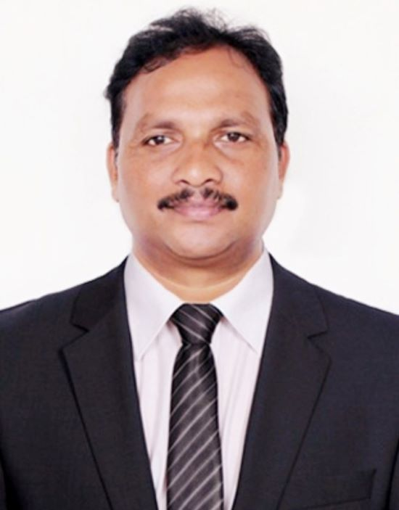
Dr.Elia Thagaram
MBA; M.Phill; Ph.D
Dean, Innovation & Entrepreneurship,
K.S.R.M. College of Engineering,
Kadapa, Andhra Pradesh, India
Email: dr.eliathagaram66@gmail.com

Dr. Elia Thagaram is a distinguished academic leader, innovation strategist, and entrepreneurship mentor with nearly 20 years of rich experience in higher education, research, innovation, and startup ecosystem development. As Dean – Innovation & Entrepreneurship, he has been instrumental in fostering a vibrant culture of creativity, design thinking, and entrepreneurial excellence across engineering and management institutions.
An accomplished educator, Dr. Thagaram has taught Entrepreneurship, Innovation, and Design Thinking to thousands of students from diverse universities and colleges across India. His engaging teaching style, practical approach, and inspiring mentorship have empowered aspiring innovators and entrepreneurs to transform ideas into impactful ventures.
He has successfully served as Chief Executive Officer (CEO) of multiple incubation centres, where he played a pivotal role in nurturing startups, strengthening industry–academia collaboration, promoting technology commercialization, and facilitating innovation-driven ecosystems. His leadership has significantly contributed to institutional capacity building and entrepreneurial development.

Dr. Thagaram is also an active researcher with an impressive portfolio of scholarly contributions, including publications in SCI, Scopus-indexed, and UGC Care journals. His expertise spans innovation management, entrepreneurship development, design thinking, startup incubation, technology transfer, and capacity building. With his visionary leadership, extensive academic experience, research excellence, and unwavering commitment to nurturing innovation and entrepreneurship,

Dr. Elia Thagaram is exceptionally well qualified to serve as the Executive Director of the National Council for Innovation & Entrepreneurship (NCIE), New Delhi, and to lead the organization toward creating a stronger national innovation and startup ecosystem.

2.
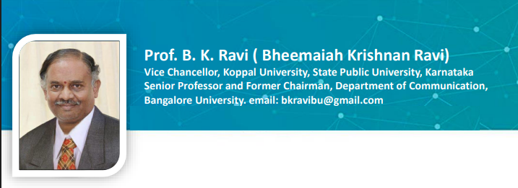

3.
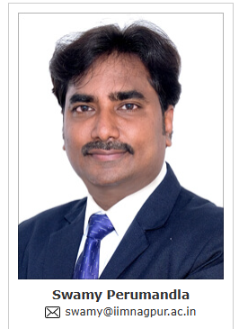

Professor. Swamy Perumandla is Chairperson and Professor in the Finance and Accounting Area at Indian Institute of Management Nagpur (IIM Nagpur), Maharashtra, India. He has over 13 years of teaching, research, executive learning, and training experience at various management institutes in India. He published several publications in ABDC, SCI and SSCI in reputed journals reflecting his significant academic contributions to the field. He earned his Ph.D. in Finance from the National Institute of Technology Warangal (NIT Warangal), India. He also qualified for the National Eligibility Test (NET). He is certified as an IICA (Indian Institute of Corporate Affairs) Resource Person. Additionally, he served as a SEBI empanelled financial education Resource Person.

4.
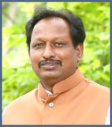 | Prof. D. Sreeramulu  MBA,LLB,PhD  Senior Professor (Marketing & G.Mgt)  Department of Management  OSMANIA UNIVERSITY, Hyderabad  Telangana, INDIA.  30 Years of Teaching Experience  6 Scholar Completed PDF  30 Scholars Awarded PhDs  82 Articles Published in Journals  Authored 3 Books  Books Edited 10  NAAC Peer Team Co-Ordinator & Member  AICTE Inspection Committee Member  Projects Completed 2 (UGC & AICTE)  Email: profsreeramulu@gmail.com  Vidwan ID: vidwan.inflibnet.ac.in/profile/593964

5.
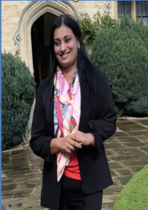
Dr. Sapna S is a Doctorate from the National Law School of India University (NLSIU), Bengaluru. She is currently serving as Dean, School of Law, Dayanand Sagar University, Bangalore.
Dr. Sapna is a distinguished Gender Consultant with the Department of Labour, Government of Karnataka, where she has made significant contributions to gender capacity building and legal advocacy. She led the initiative for the Menstrual Leave Policy for the Government of Karnataka and has been actively engaged in policy recommendations with the Karnataka Institute of Legal and Parliamentary Affairs. She has successfully conducted sensitization programmes on laws relating to Prevention of Sexual Harassment across 8 districts of Karnataka, and delivered 18 sessions for ISRO along with numerous training programmes for various private entities.

6.
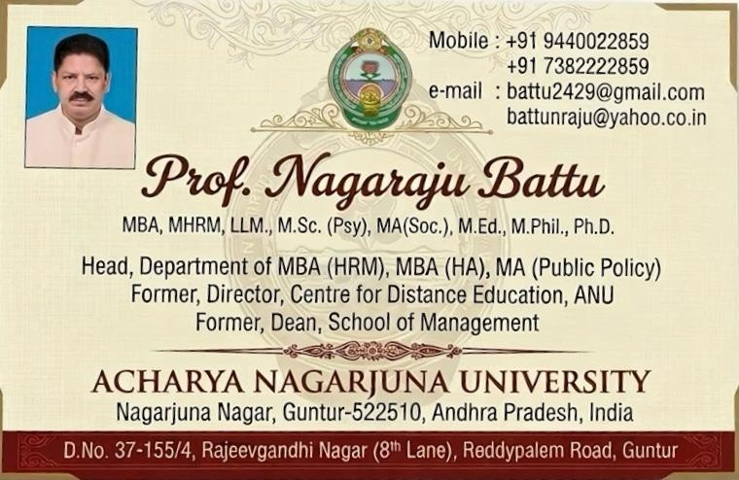

7.
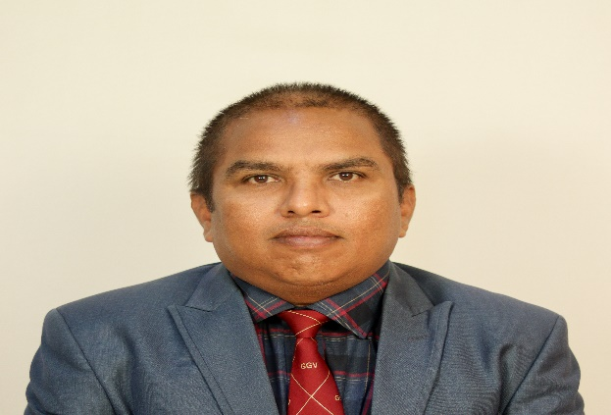
Dr. Vijaya Kumar
Assistant Professor
19 years of Teaching Experience,
Department: Pure & Applied Physics
Guru Ghasidas Vishwavidyalaya (A central University, act 2009), Department of Pure & Applied Physics, Koni, Bilaspur, Chhattisgarh, India.

8.

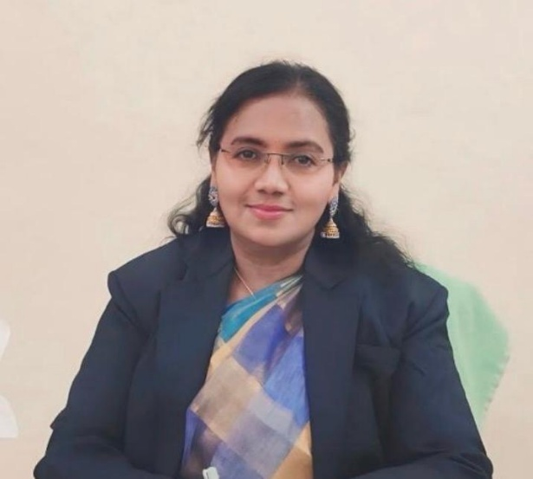

DR. K. SUVARNA LATHA
Ph.D. (Structural Engineering) · M.Tech · B.Tech (Civil)
Principal, Government Polytechnic for Women, Secunderabad
Department of Technical Education, Government of Telangana.
Email: latha_suvarna@yahoo.co.in

Teaching & Administrative Experience: 30+ years in technical education
Current Position: Principal, Government Polytechnic for Women, Secunderabad — Department of Technical Education, Government of Telangana
Her professional journey reflects dedication, integrity, innovation, and a strong vision for transforming technical institutions into centres of excellence. She has successfully led several academic, administrative, and infrastructure development initiatives that have significantly strengthened the technical education ecosystem in Telangana.

ADVISORY BOARD-NICE
1.
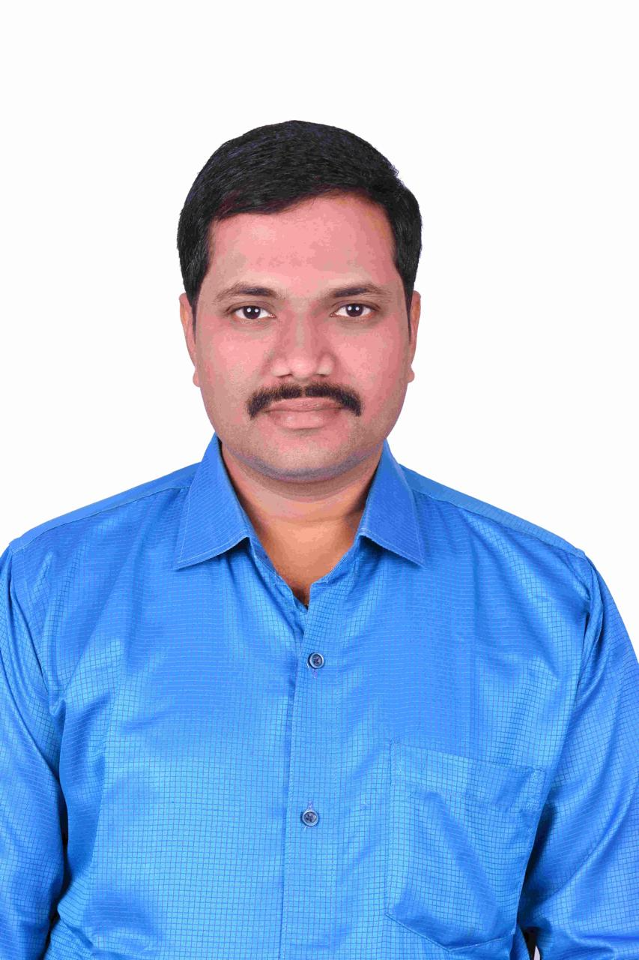
Email: prameshbabu526@gmail.com
Dr. P. Ramesh Babu is a distinguished academician, researcher, administrator, and technology leader with over 22 years of experience in higher education, research, academic administration, and industry-oriented training. He is currently serving as Professor at the C.R. Rao Advanced Institute of Mathematics, Statistics and Computer Science (AIMSCS), University of Hyderabad Campus, Hyderabad. Throughout his career, he has held several prestigious academic and administrative positions, including Professor, Associate Professor, and Head of the Department, Vice Principal, NBA Coordinator, and Academic Council Member at reputed engineering institutions across India.

2.
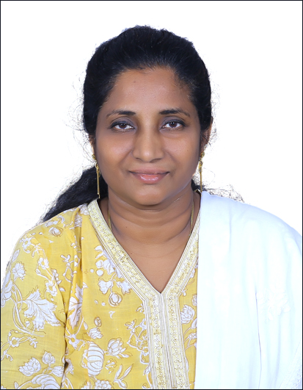
Brief Profile
Dr. Vadranang Swarna Latha is an accomplished academician with over 24 years of teaching experience in the fields of Printing Technology, Packaging Technology, and Spatial Information Technology (GIS).
She completed her B.Tech in Printing Technology from JNTU Hyderabad, followed by an M.Tech and Ph.D. in Spatial Information Technology from JNTU Hyderabad. She also holds a B.A. in Geography through the Open Stream from Osmania University.

3.
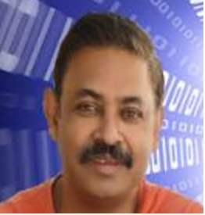

Dr. Navneet Goyal

Senior Professor

Department of Computer Science & Information Systems
Birla Institute of Technology & Science (BITS), Pilani Campus
Pilani – 333031, Rajasthan, India
His key areas of expertise and research interests include Artificial Intelligence and Machine Learning (AI/ML) for Cyber Security, Big Data Analytics, Data Mining, Data Provenance, and IoT Data Analytics.
Office: Room No. 6121-K, New Academic Building
Email: goel@pilani.bits-pilani.ac.in
Alternate Email: bitsngoyal@gmail.com

4.
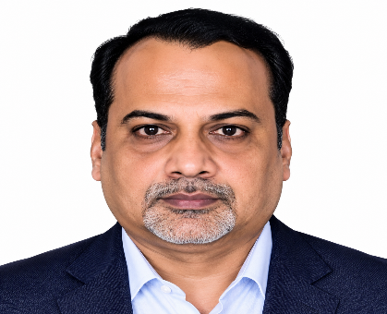
Principal & Senior Professor, Allampalli Venkataram Labor Research Chair
Director, Dean Faculty of Law, & officiating Vice-Chancellor at Bangalore University,
Bengaluru, Karnataka, India.

5.
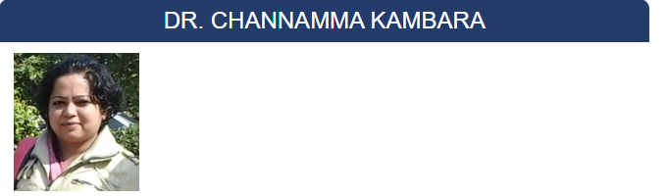
Assistant Professor
Centre for Research in Urban Affairs (CRUA)
Institute for Social and Economic Change
Nagarabhavi P.O. Bangalore 560072, India.
Tel: Office: 080-23215468, 23215519, Fax: 080-23217008
Email: channamma@isec.ac.in

6.
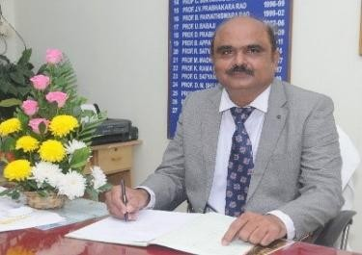

PROF. JALADI RAVI
M.Com., MBA., Ph.D.,
Department of Commerce and Management Studies,
Andhra University, Visakhapatnam, Andhra Pradesh
Email: dr.ravijaladi@gmail.com
Prof. Jaladi Ravi, M.Com., MBA., Ph.D., is a distinguished academician, researcher, administrator, and management education professional with over 30 years of teaching and academic experience. An outstanding record in research supervision and scholarly contributions. Under his guidance, 43 research scholars have successfully completed their Ph.D. degrees, while six scholars have completed their M.Phil. degrees. He has also guided three Post-Doctoral Fellows (PDFs
7.
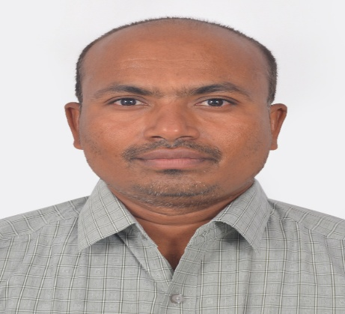

Brief Profile –
Dr. Ponnam Anjaneyulu
Associate Professor,
Department of Physics,
Central University of Karnataka,
Kalaburagi, Karnataka.

Dr. Ponnam Anjaneyulu is an accomplished academician and researcher in Physics, currently serving as Associate Professor in the Department of Physics, Central University of Karnataka, Kalaburagi. He obtained his Ph.D. in Physics from the Indian Institute of Science (IISc), Bengaluru, with specialization in Experimental Condensed Matter Physics (Organic Semiconductors). He holds an M.Sc. in Physics from the University of Hyderabad and has over 13 years of teaching and research experience.

8.
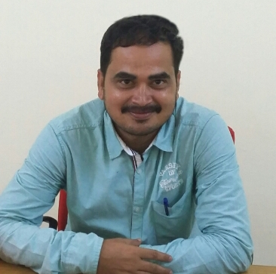
Dr. Gugulothu Srinu
Assistant Professor
Department of Public Administration and Policy Studies
18 Years of Teaching Experience
Central University of Kerala
Tejaswini Hills
Central University of Kerala (P O)
Kasaragod (DT), Kerala-671325
INDIA
Email: gsrinivas62@gmail.com

